Online Data Entry System using Google App Engine

14bce024, 14bce029

* Abstract-

For organising any event the most important part is to handle the data entry. If we talk about the traditional system of data entry it will involve lot of paper work and then managing the same database is tedious task. For overcoming this problem we have used the cloud computing services provided by the google on free basis up to certain limits. Here the database used is NoSql and all entries will be stored in form of key value pairs with unique 16 digit key. So it is faster and reliable than the traditional database system. It is like a web application so user can make data entry from any location provided that he has access to the internet.

Now google app engine gives us flexibility regarding the language for implementation like Python, Java or Go. We have done the implementation in python. This implementation will have two parts first is front end and other one is back end. Front end will have form kind of appearance and used HTML and bootstrap for it. The important part is backend and it is completely written in python. It contains all the methods and the data entry rights in it.

* Flow diagram-

User

(User that will do the

Data entry)

User authentication

Starting.py script

Contact the google app engine cloud service

Google app engine

Yes

Google Data store

Store all the data entries to the google data store

For showing all entries in tabular form

* Features of python used-

Here we have used 3 major libraries of python

1.urllib

2.jinja 2

3.webapp 2

1. Urllib

It provides the high level interface to fetch the data from the world wide web. The function urlopen will use the URL to for fetching the data from that particular source.it will open url’s only in read mode we did not have seek option here.

1. Jinja2

Jinja 2 is the user friendly templating language for python. It is fast,secure and widely used. We have used this for loading the python environment with the HTML pages.

1. webapp2

Webapp2 is the lightweight python web framework compatible with the google app engine. It provide simplicity to the web application and better url routing. We have used the webapp2 for navigating through the web pages which are involved in the project.

* Deployment of the web service-

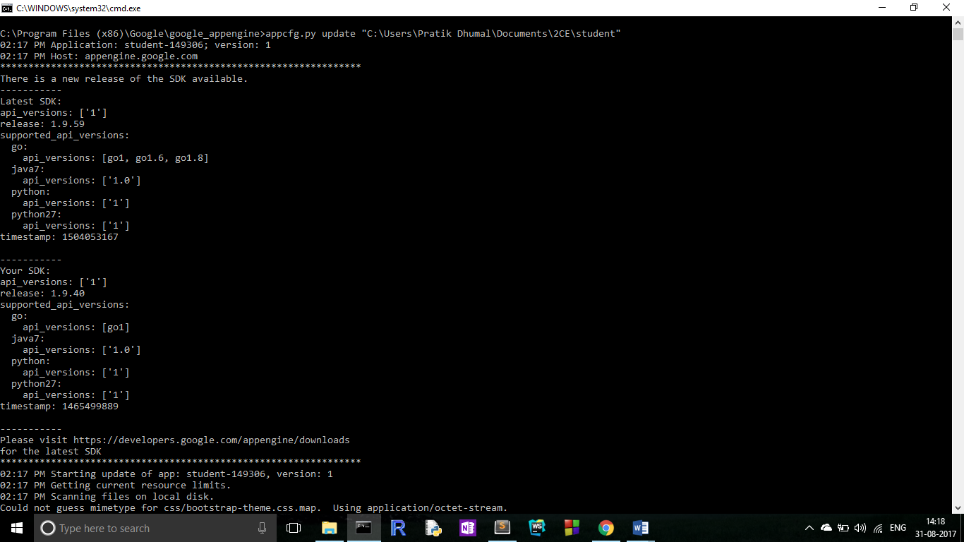

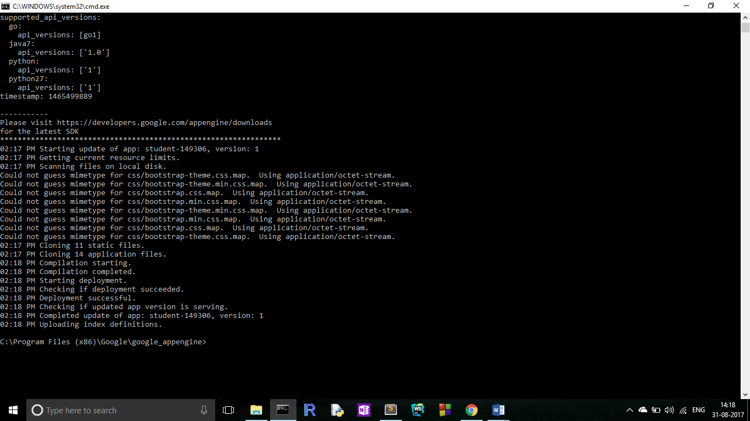

* Limitations-

1. The major limitation of this project is we are using the google cloud services which are free only up to certain limit. For additional use or for large scale use we have to purchase these services.
2. Daily capacity of these app engine is about 500 entries after that it will show the request overflow errors.
3. We required internet connection for doing entries and accessin+g the database without that we cannot do any of above thing.
4. One should have knowledge of Nosql database for building such systems.

* Conclusion-

We have used the concepts of Nosql database, cloud computing and python frameworks for this project. This system is successfully used for the data entries in event and it has reduced the heavy data managing task by many aspects due to the reliability and availability. We have managed and provided the appropriate security to the data by using features of the jinja2 library.